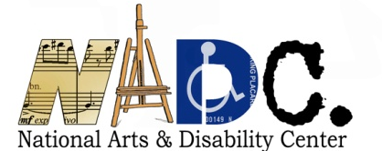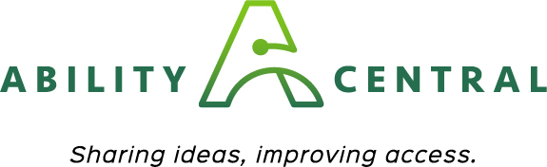

The Arts and Communication Access

Grant Application

APPLICANT INFORMATION: - PLEASE TYPE
If you need assistance in completing this application please email Beth
Stoffmacher bstoffmacher@mednet.ucla.edu so that she can assist you.

Legal Name of Applicant Organization:
Address:
City:
State:
Zip Code:
Federal EIN Number (XX-XXXXXXX):
Main Phone:
Website:
Twitter:
Facebook:
Instagram:
Applicant Contact Name and Title:
Applicant Contact Phone:
Applicant Contact Email:

How did you find out about this grants opportunity?

The nonprofit arts organization, agency or service for which funds are sought must be located in California. Please check the appropriate box to indicate your organizational type below.
Nonprofit arts organization
Local arts agency or unit of government
_____Other (please describe)

Grant Request Amount (Request up to $5,000):

Project Dates: Applications must be received at least 30 days prior to a proposed event. Projects must be completed by December 2020.
**Please note, the check will take 6-8 weeks for UCLA to process. If you need the funding to start your project, please make sure to adjust your start and end dates accordingly.

Start Date (MM/DD/YYYY):
End Date (MM/DD/YYYY):

PROJECT NARRATIVE:
- Please provide a brief project description summarizing the project and its related activities (up to 150 words). Your description must indicate how your organization will provide communication access for individuals with disabilities.

- Please provide specific details about services, supports or other activities for which you are requesting funds. If requesting support for a specific event or activity, please include the name, date, and location of the event.

- Explain how your request for communication access fits into the programmatic activities of your season. How will the support assist you in offering something new?

BUDGET AND BUDGET JUSTIFICATION:
A detailed budget and explanation is required. Refer to Section H in the Grant Guidelines for a sample budget for Arts Organizations. Include a) any matching funds or in-kind support and b) a line item for appropriate communication access. Submit a budget page with your application or use the space below.

ORGANIZATIONAL CAPACITY:
- Please provide an overall description of your organization. Include your mission, communities you serve, and relevant arts-related activities produced within the last 5 years. Attach an additional page, if necessary.

- Please to indicate your organization’s previous experience with artists and audiences with disabilities. Check all that apply:
____Provide annual and/or frequent staff training on accessibility
____Have designated staff responsible for accessibility oversight
____Have one or more persons with a disability on staff
____Have one or more persons with a disability serving on the Board/Advisory
Committee
____Maintain an organization-wide access policy
____Maintain accessible facilities
____Maintain an accessible website
____Include accessibility accommodations as a budget line item for all events or activities
____Include access information/accommodations on all publicity and marketing
materials with appropriate disability access symbols

- Has your organization previously hired or provided communication access to artists or audiences with disabilities? If so, please describe the kinds of opportunities that were offered through this programming.

INFORMATION DISSEMINATION:
Please describe how you will provide information to the public or potential participants about your program's accessibility and the availability of services.

Supporting Materials: Attach to your application no more than 4 supporting materials confirming details of the proposed project. This may include program descriptions, brochures, flyers, or other information about the proposed project or your activities.

STAFF ASSISTANCE AND PROPOSAL SUBMISSION:
NADC staff is available to offer guidance, clarification, and general technical assistance in preparing your proposal.

Staff Contact:
Beth Stoffmacher, NADC Arts Specialist bstoffmacher@mednet.ucla.edu

To Submit Your Application:
All proposals must include the Application Checklist on the final page of this application and all requested support materials. Applications must be received at least 30 days prior to a proposed event.

All proposals must be submitted by email using the official Grant Application and signed by an authorized representative of the Applicant Organization.

Please submit your application to Beth Stoffmacher, NADC Arts Specialist bstoffmacher@mednet.ucla.edu

ARTS ORGANIZATION APPLICATION CHECKLIST AND SIGNATURE:
Check boxes below and submit this signed page with your application
Our organization is a California nonprofit arts organization, local arts agency or unit of government and meets all eligibility requirements as per the Grant Guidelines
Our organization is not a school, college or university
All proposed activities and services funded will occur within California
All activities will be completed by December 30th, 2020
Supporting materials pertaining to the proposed project are attached

SIGNATURE:
If awarded, our organization agrees to the following in relation to the funded project and activities: 1) publicize and market information regarding communication access; 2) use the NADC and Ability Central Philanthropy logos on all relevant printed and electronic materials; 3) include the following language on all printed and electronic materials: “This activity is funded in part by the National Arts and Disability Center at the University of California Los Angeles and Ability Central Philanthropy”; and 4) provide verbal credit when discussing the project and activities supported by this grant.

I, the undersigned, certify that I am an authorized organizational representative with the knowledge of the matters contained herein, and that I hold the legal authority to obligate the organization, with the approval of the organization’s board of directors or other governing body.

Furthermore, I certify that the information contained in this application is true and accurate to the best of my knowledge. I have kept a copy of this application for our organizational records.

________________________________ _____________________
Signature* Date

* An electronic or digital signature may be used.

